**Set and Dictionary Methods**

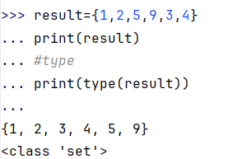

**add():**Adds an element to the set

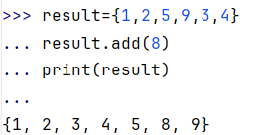

**clear():**Removes all elements from the set

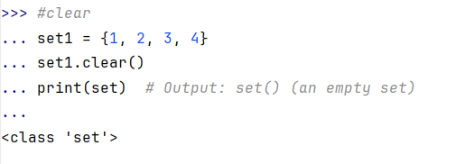

**difference():**Returns the difference of two or more sets as a new set

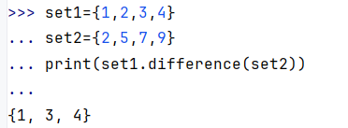

**difference_update()**:Removes all elements of another set from this set

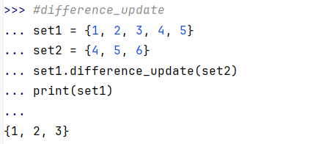

**discard():**Removes an element from the set if it is a member. (Do nothing if the element is not in set)

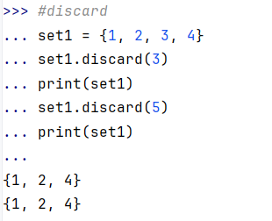

**intersection():**Returns the intersection of two sets as a new set

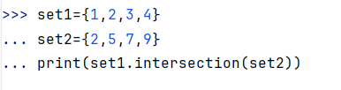

**intersection_update():**Updates the set with the intersection of itself and another

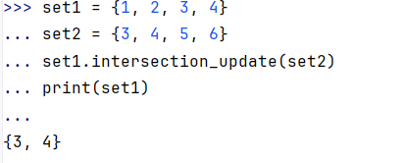

**isdisjoint():**Returns True if two sets have a null intersection

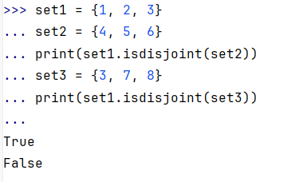

**issubset():**Returns True if another set contains this set

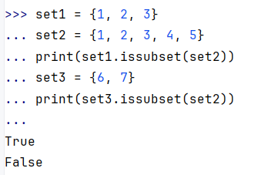

**pop():**Removes and returns an arbitrary set element. Raises KeyError if the set is empty

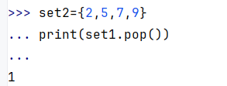

**remove():**Removes an element from the set. If the element is not a member, raises a KeyError

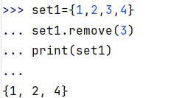

**symmetric_difference():**Returns the symmetric difference of two sets as a new set

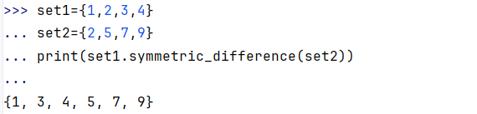

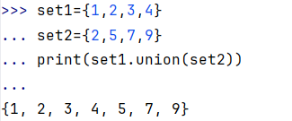

**update():**Updates the set with the union of itself and others

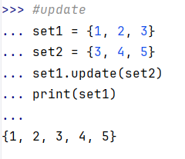

**all():**Returns True if all elements of the set are true (or if the set is empty).

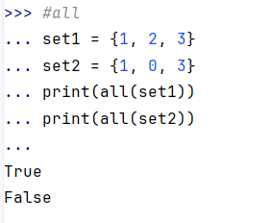

**any():**Returns True if any element of the set is true. If the set is empty, returns False.

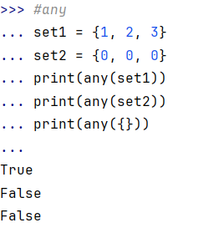

**len():**Returns the length (the number of items) in the set.

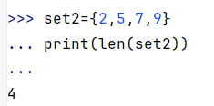

**max()**

Returns the largest item in the set.

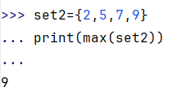

**sorted()**:Returns a new sorted list from elements in the set(does not sort the set itself).

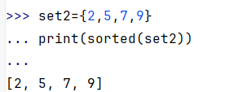

**Dictionary**

**get(key[,d])**:Returns the value of the key. If the key does not exist, returns d (defaults to None).

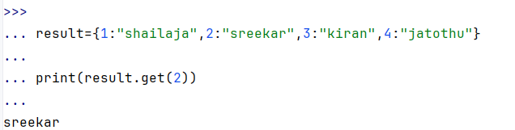

**keys():**Returns a new object of the dictionary's keys.

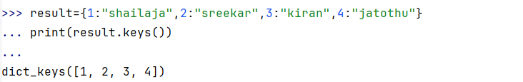

**values():**Returns a new object of the dictionary's values

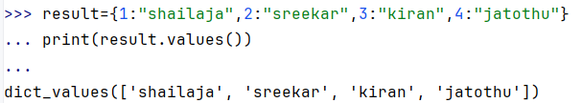

**update([other]):**Updates the dictionary with the key/value pairs from other, overwriting existing keys.

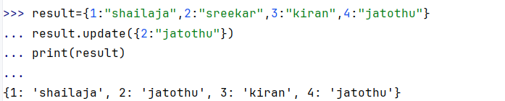

**items():**Return a new object of the dictionary's items in (key, value) format.

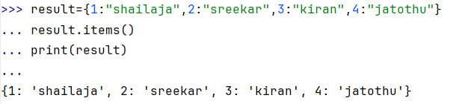

**popitem()**:Removes and returns an arbitrary item (key, value). Raises KeyError if the dictionary is empty.

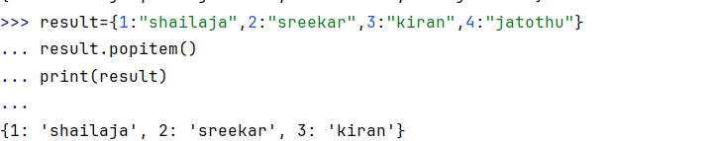

**clear()**:Removes all items from the dictionary.

